Citi Bike Data Analysis

Tableau public access to presentation: <https://public.tableau.com/app/profile/amy.brunet/viz/CitiBikeAnalysis_16431539860350/CitiBikeDataAnalysis>

\*Due to the size of the dataset, a random sample of 15,000,000 rides was extracted to perform this analysis.

Upon analyzing the Citi Bike ridership data for 2019, several phenomena were uncovered. Through this analysis, some insights have been discovered that will help to inform business decisions and aim to increase profits moving forward.

The first phenomena that was analyzed was the demographics of total ridership broken down by gender. On the first dashboard, it is evident that there is a very large gap in the number of male and female riders. Riders identifying as female only account for around 26% of total users, while the riders identifying as male account for the other 74%. It would be in the company’s best interest to invest some time and money into developing marketing campaigns or incentive programs geared toward individuals who identify as female to increase interest and use of Citi Bike in New York City. Conducting surveys or focus groups of participants identifying as female could help to provide insight into why so many choose not to use the bikes, and conversely, surveys and focus groups on users identifying as male could provide answers as to why so many do choose to ride the bikes.

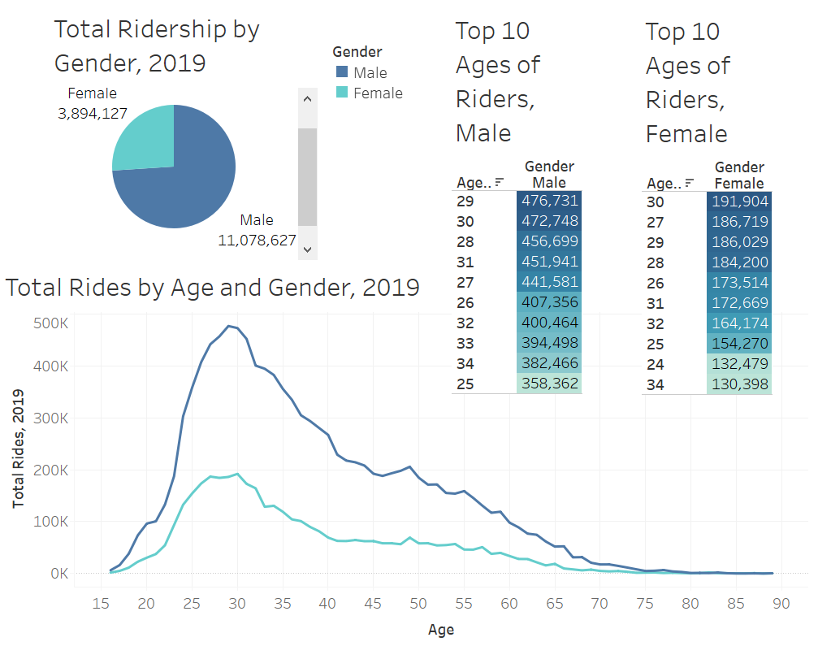

Further analysis of the gender breakdown provides information on the demographics of riders who use Citi Bike most often. The top 10 ages of users identifying as male range from 25-34, and users identifying as female is about the same ranging from 24-34. The top users of the bikes are 29-year-old males and 30-year-old females. Additional marketing and/or programming could help incentivize users of ages outside that range to participate in use of the bikes as well.

The second phenomena uncovered was in the breakdown of the peak times of ridership throughout the day, week and year. The peak times throughout week are relatively steady, with the least riders on Sundays and the most riders on Tuesdays and Wednesdays. Further breakdown of the days shows that the peak times to start a ride are between 8am-9am and 5pm-6pm. These peak times strongly correlated with commuters going to and from work. In addition, there are more riders in the afternoon hours than in the morning hours, with very little ridership from midnight to 5am. Looking at the breakdown of peak times and gender shows that riders identifying as male and riders identifying as female have similar peak start times throughout the day, but females have a more consistent ridership throughout the days of the week than males.

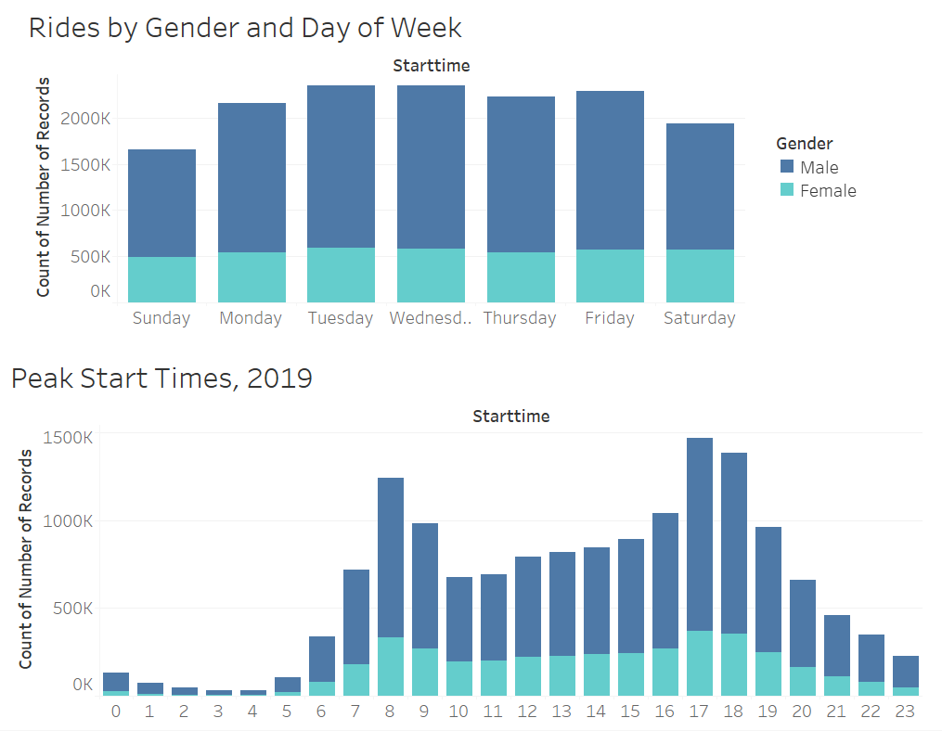

On a larger scale, the peak times for each month grouped by summer months and winter months was analyzed. As suspected, there is an increase in ridership throughout the summer months, most likely due to the warmer weather and the increase in daylight hours. December sees the greatest decrease in ridership, and June and September see the greatest increase. The peak times stay relatively consistent throughout the year, with the peak times being between 8am-9am and 5pm-6pm. Additionally, like mentioned above, there continues to be more ridership in the afternoon hours than in the morning 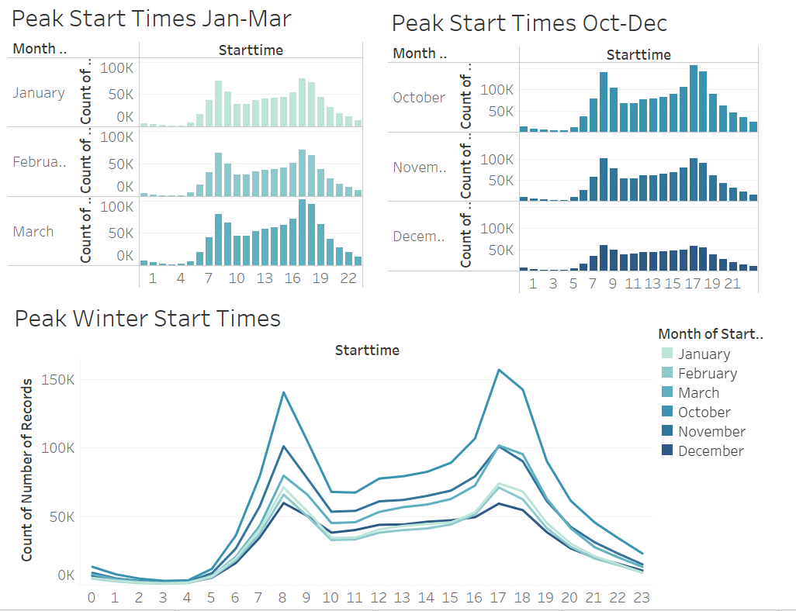hours consistently throughout the year.

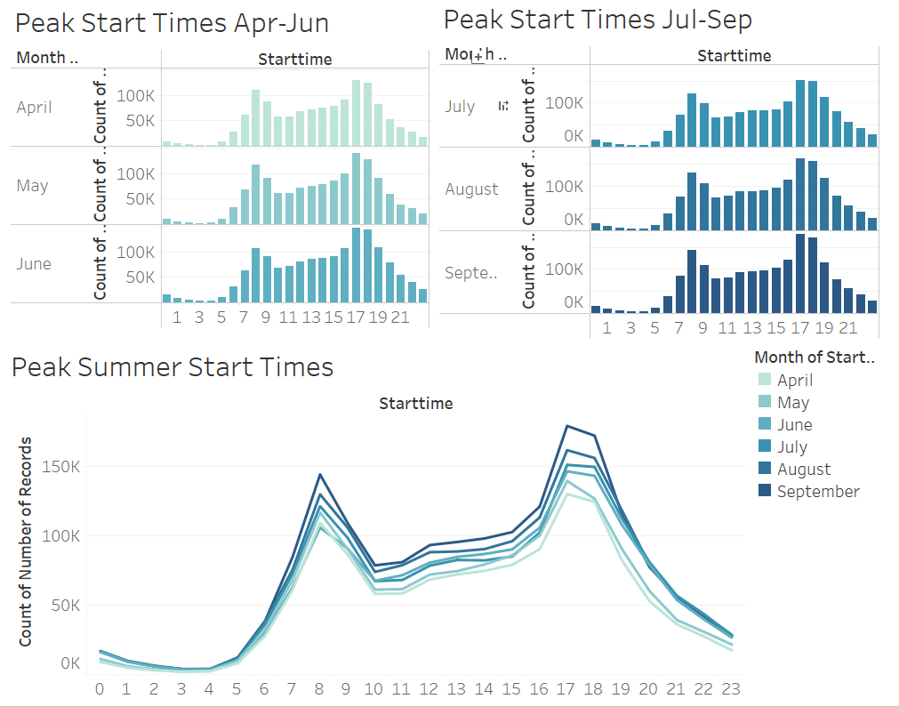

Finally, the third phenomena uncovered through the analysis was the most popular start and end stations throughout the year. The most popular station to start and end a ride was Pershing Square North. The top 10 most popular stations to start and end a ride are in the middle of the city which provides a central and convenient location for riders. During the summer months when there is increased tourism, these stations provide easy access for tourists to explore the city. The lesser popular stations are in more residential, less central locations which may only be used by residents of that particular area. Providing incentives for riders in areas outside of central NYC could help increase ridership at some of the lesser utilized start and end stations.

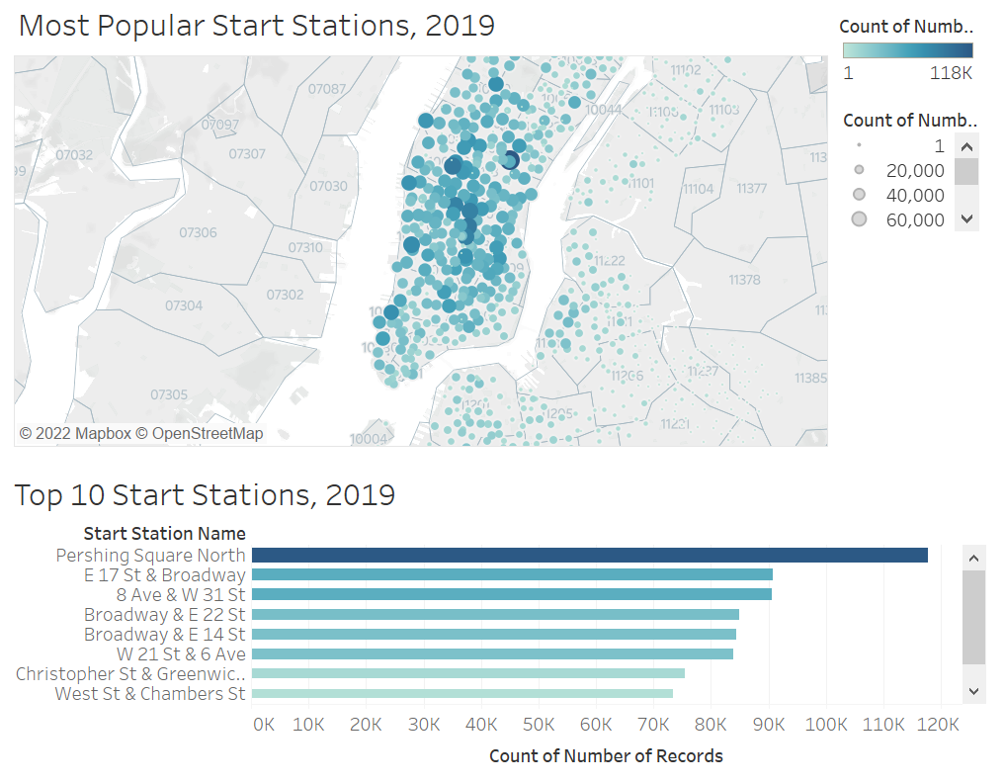

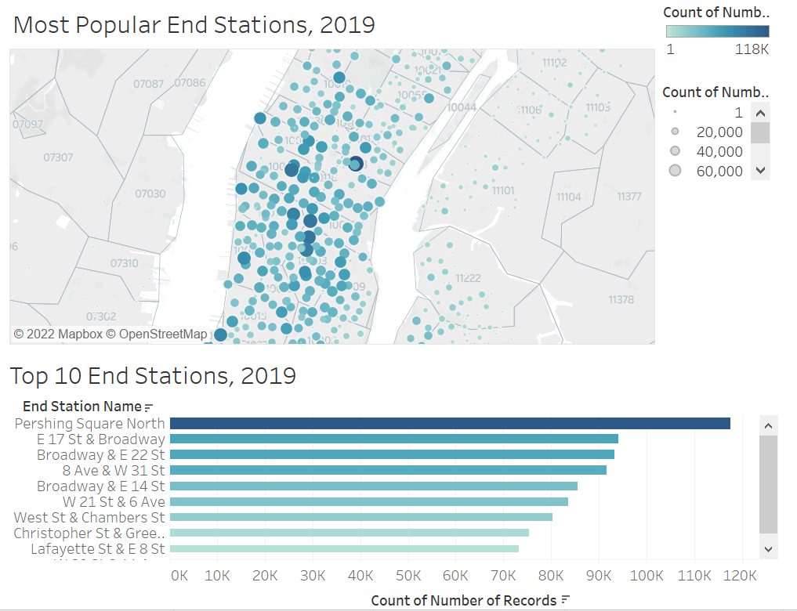

Using this data, Citi Bike can make more informed decisions on how to increase ridership for those demographics that aren’t using the bikes as frequently or at all. The biggest demographic to target would be the riders identifying as female based on the large discrepancy between male identifying and female identifying riders. Increasing female identifying ridership would lead to a much larger profit for the company. Additionally, providing incentives for riders throughout the day, outside of peak times, would be another opportunity for growth and profit. Overall, Citi Bike has done a great job of providing people in New York City an affordable, convenient, and eco-friendly mode of transportation. With these insights, they could expand and make riding their bikes an integral part of NYC’s daily routine.